SQL LAB-5

Group By

**NAME: Pravallika Ullikanti**

**ID: AF0366355**

QUESTIONS

Lab 2-

Database Schema:

Use the same database scheme created in Previous Lab.

Task: Let's consider a scenario where you want to count the number of students based on their gender from a database table named Student.

Hint: use GroupBy clause and Count() function

ChatGPT Exercise Using ChatGPT generates SQL queries of the below problem . Scenario 1:

Library Books Given a table called books with columns book_id, title, and author_id, write a query to count the number of books written by each author, ordering the results by the author's name without using a join clause.

## Task: Let's consider a scenario where you want to count the number of students based on their gender from a database table named Student.

**Hint: use GroupBy clause and Count() function**

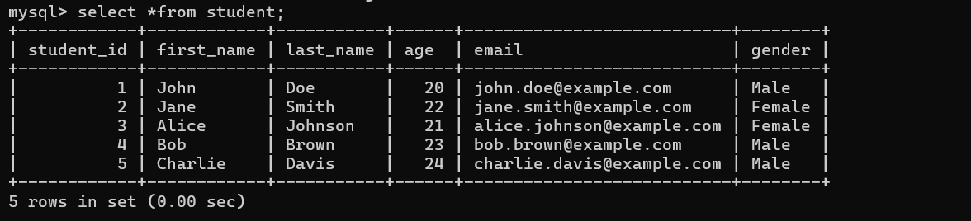

**Code & Output:-**

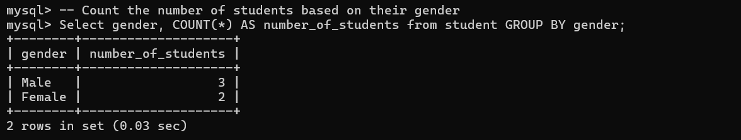

## ChatGPT Exercise

**Using ChatGPT generates SQL queries of the below problem . Scenario 1:**

## Library Books Given a table called books with columns book_id, title, and author_id, write a query to count the number of books written by each author, ordering the results by the author's name without using a join clause.

--Create bookst database and use the bookst database environment

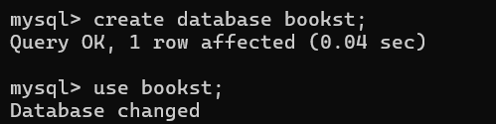

**--** Creating the new table named books

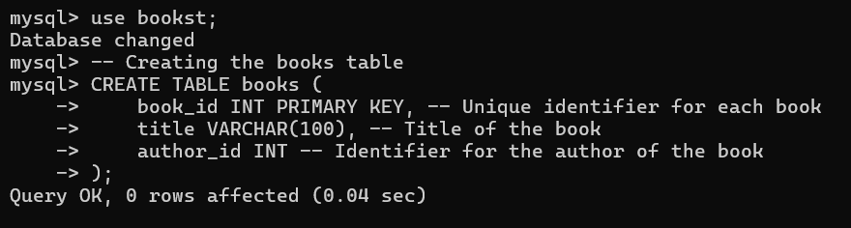

# --Inserting the values into the books table

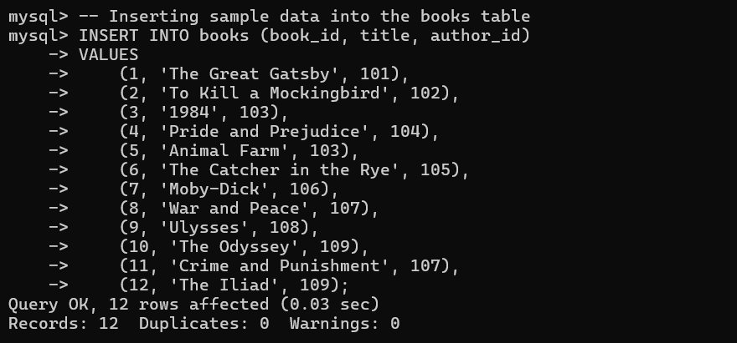

**--Display the books table**

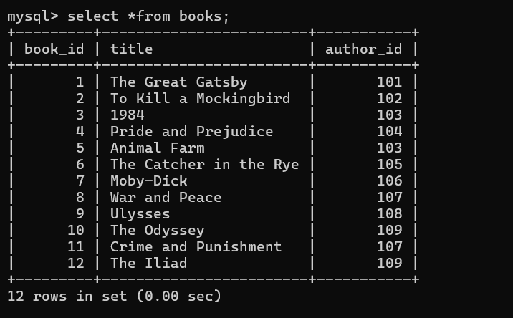

# --Adding the author_name column and insert the values into the books table

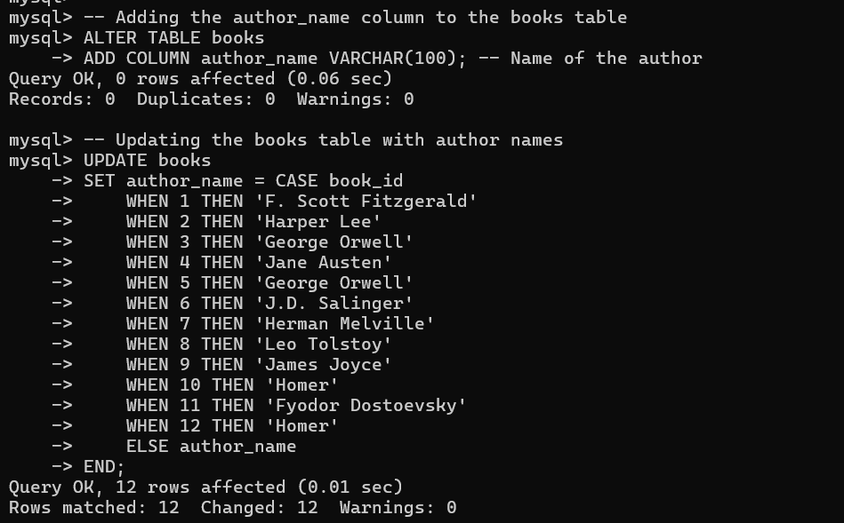

**--Display the books table**

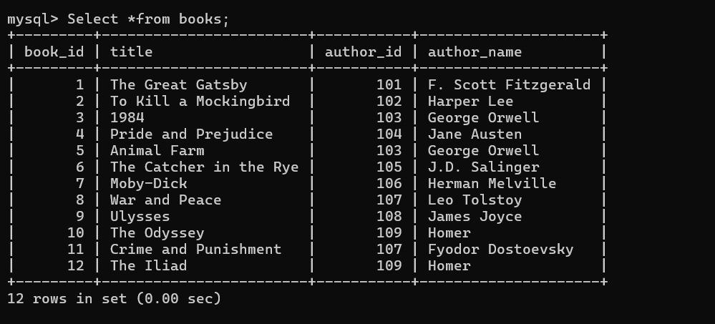

# Code & Output:-

